

PRACTICAL -8
Binary Tree Traversals and Binary Search Tree Insertion

Practical Aim
To implement binary tree traversals and binary search tree insertion, and develop the ability to reason about how the order of visiting nodes changes the information retrieved from a tree.

Problem 1
A company stores its organizational hierarchy as a tree — the CEO at the top, managers below, and employees at the leaves. Different departments need the hierarchy printed in different orders: HR wants each manager printed between their left and right sub-teams, the archive department wants each manager printed before their sub-teams, the payroll department wants each manager printed after all their sub-teams are listed, and the floor manager wants everyone printed level by level from top to bottom. Given a binary tree representing the hierarchy, implement all four printing orders and display the result of each.
Describe how your solution for level-by-level printing differs from the other three. What additional structure did you need to use, and why does the same recursive approach that works for the other three not directly apply here?

CODE LINK:
https://github.com/nishee166/FDSA-Batch--B-SHP-.git

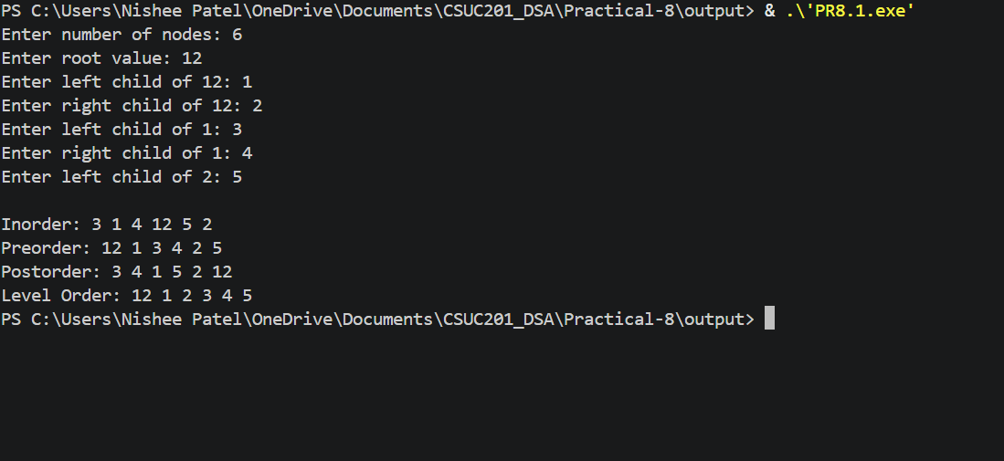

Error Faced:
I initially did not check whether a child was NULL before adding it to the queue in level order traversal, and the program crashed.
Learning:
I learned how a queue helps to visit nodes level by level, and how the order of visiting nodes changes the output of each traversal.
Solution:
I added conditions to check that the left and right children are not NULL before adding them to the queue.
Problem 2
A school library uses a system where every book is assigned a unique code when it arrives. Books are organized so that at any shelf position, all books to the left have smaller codes and all books to the right have larger codes. This arrangement lets staff find any book quickly by always knowing which direction to look. Given a sequence of book codes arriving one by one, insert each into the correct position and print the inorder sequence after all insertions are complete.
Describe how your solution decides where to place each new book code. What property of the final inorder sequence tells you whether all insertions were performed correctly?

CODE LINK:
https://github.com/nishee166/FDSA-Batch--B-SHP-.git

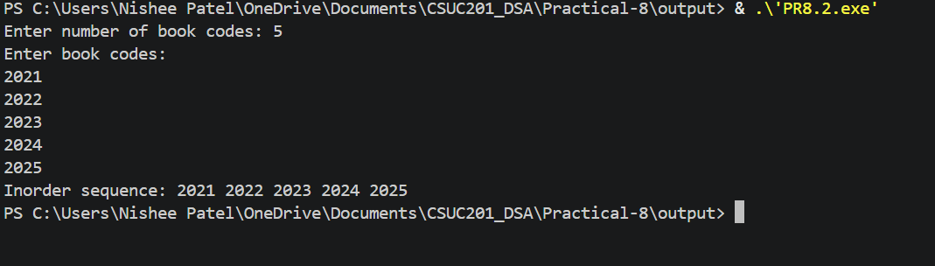

Error Faced:
I initially did not return the root from the insert function, so the new nodes were not linked to the tree and the inorder output was empty.
Learning:
I learned how a new node is placed in a BST by comparing it with the current node and moving left or right until an empty position is found.
Solution:
I made the insert function return the root and used root = insert(root, value) so that every new node gets linked to its parent.
Key Questions:
Problem 1
Preorder traversal always visits the root before anything else. Using only this property — without tracing any tree — explain whether it would be possible to reconstruct the original tree from its preorder output alone, and what additional information you would need if it is not.

ANS:
No, it is not possible to reconstruct the tree from the preorder output alone. Preorder only tells us that the first node is the root, but it does not show which of the following nodes belong to the left subtree and which belong to the right subtree. Different trees can give the same preorder output. We need one more traversal, such as the inorder traversal, to separate the left and right subtrees.

Problem 2
The inorder traversal of a correctly built BST always produces a sorted sequence. If your inorder output is not sorted after all insertions, what does that tell you about where the error is — in the insertion logic, the traversal logic, or possibly both? How would you isolate which one?

ANS:
If the inorder output is not sorted, the error is most likely in the insertion logic, because the traversal is just left, root, right and is simple. However, both could be wrong. To isolate it, I would run the inorder function on a small tree built by hand, such as 2, 1, 3. If it prints a sorted output, the traversal is correct and the fault is in the insertion logic.

Conclusion
The practical successfully implemented the four binary tree traversals and binary search tree insertion. I learned how the order of visiting nodes changes the output, why level order traversal needs a queue, and how the inorder traversal of a BST gives a sorted sequence.

